MODULE 3 :- Python
PYTHON OVERVIEW
SUBMITTED BY :- CHANDAN YADAV KS
SUBMITTED TO :- VIKUL
DATE OF SUBMISSION :- 26-05-2025

1. L1 - In Local Windows Machine Install and setup Environment Variable for Python
STEP1 : Install the python
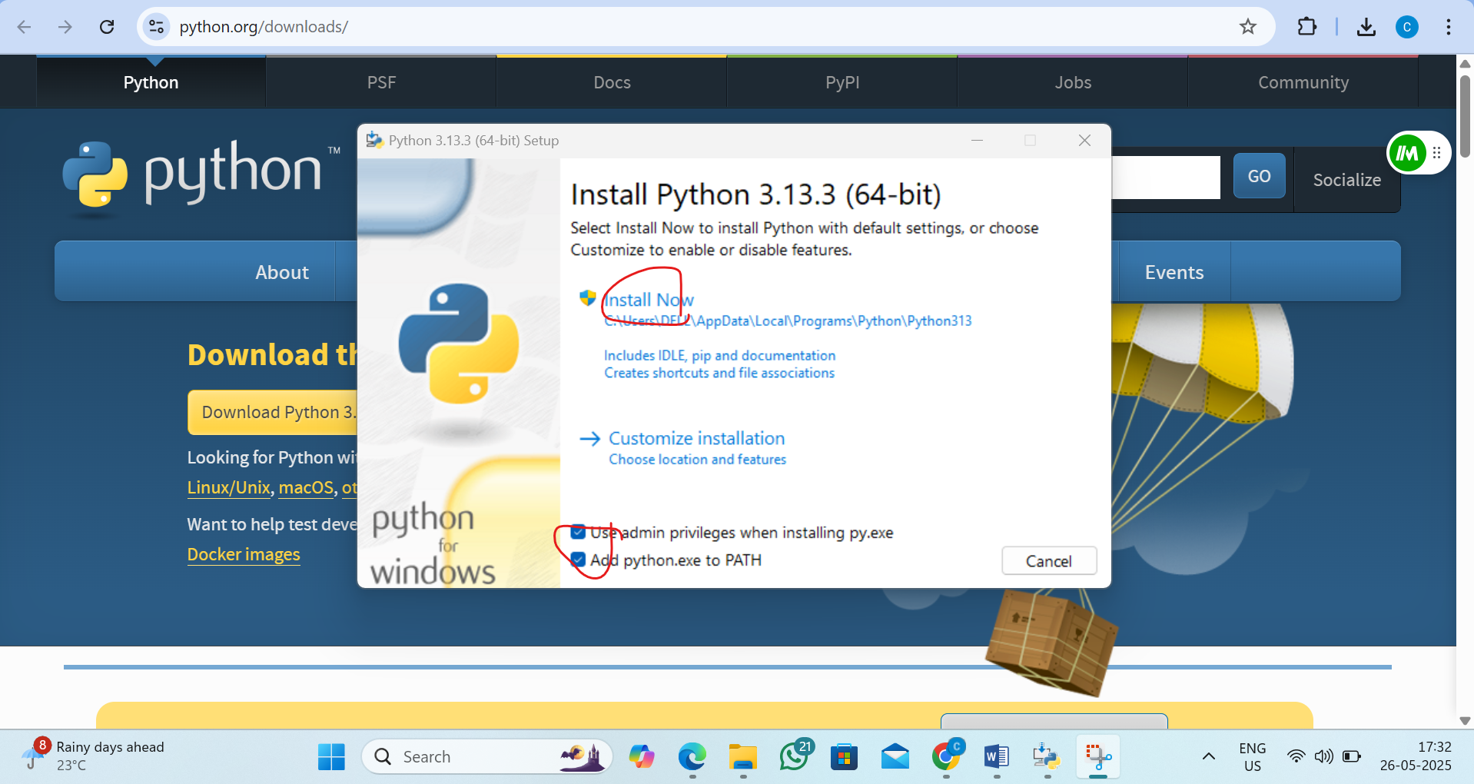
Step2 :copy the python floder location
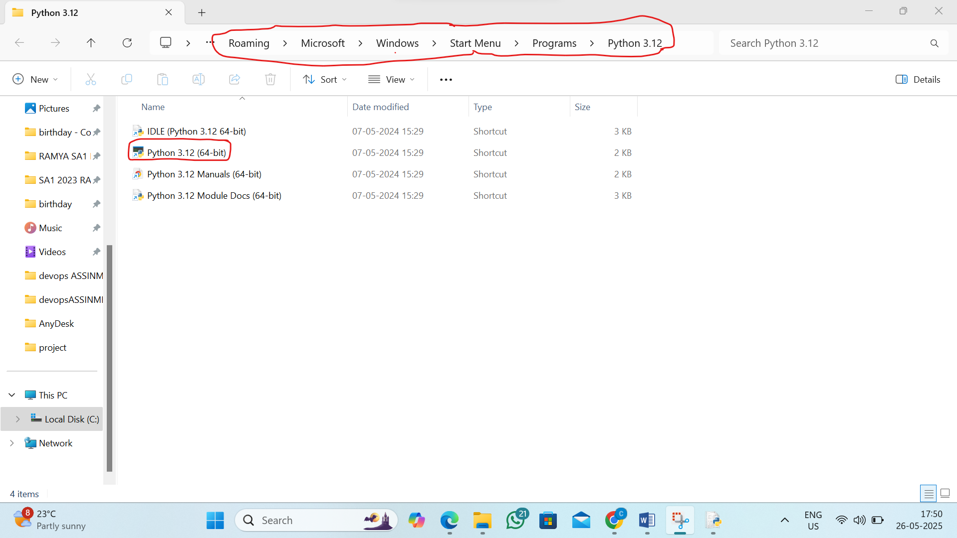

Step3 : Add to Environment Variable
Follow the steps
- Press Windows + S, type Environment Variables, and open it.
- Under System variables, click on Path → Edit
- Click New and paste the path
- Also add the Scripts folder path:
- Click OK on all dialogs.
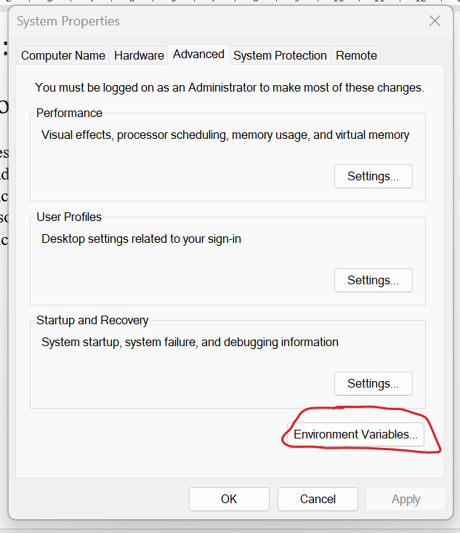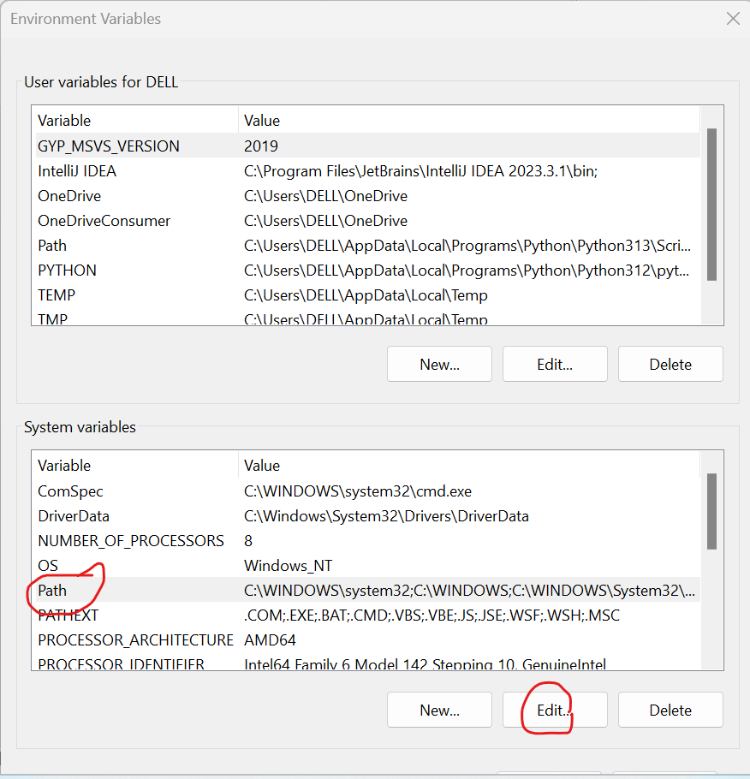
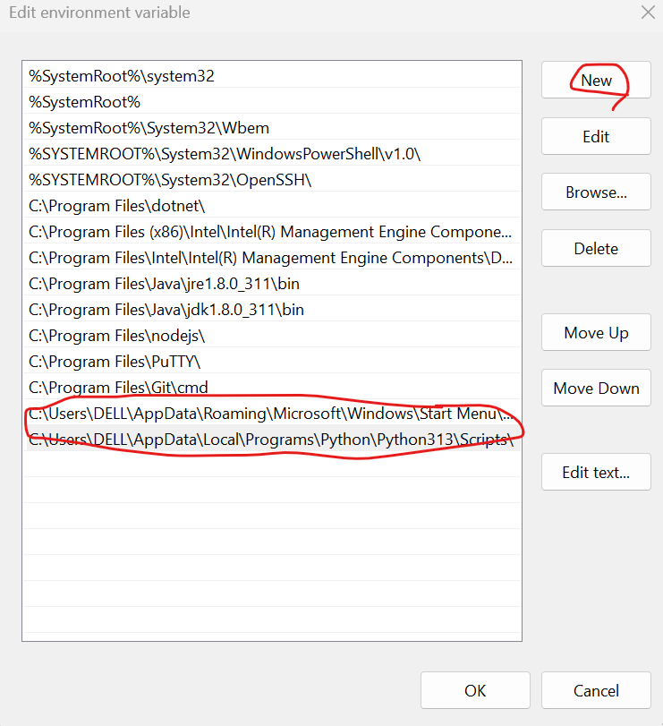

Step4: Test in Command Prompt
By the command: python –version
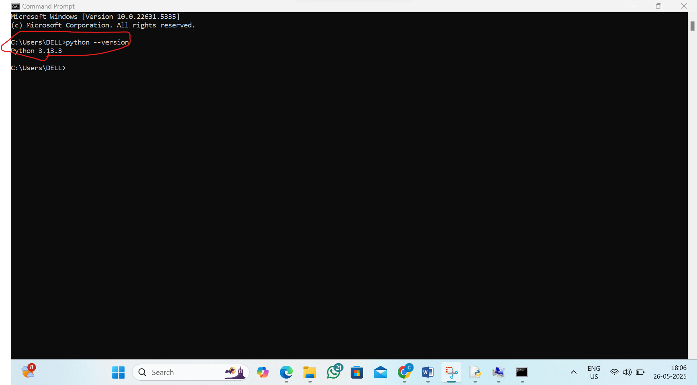

2. L2 - Install Visual Studio Code and Install Python and Terraform Extensions in VS Code
Step 1: Install Visual Studio Code (VS Code) and open it
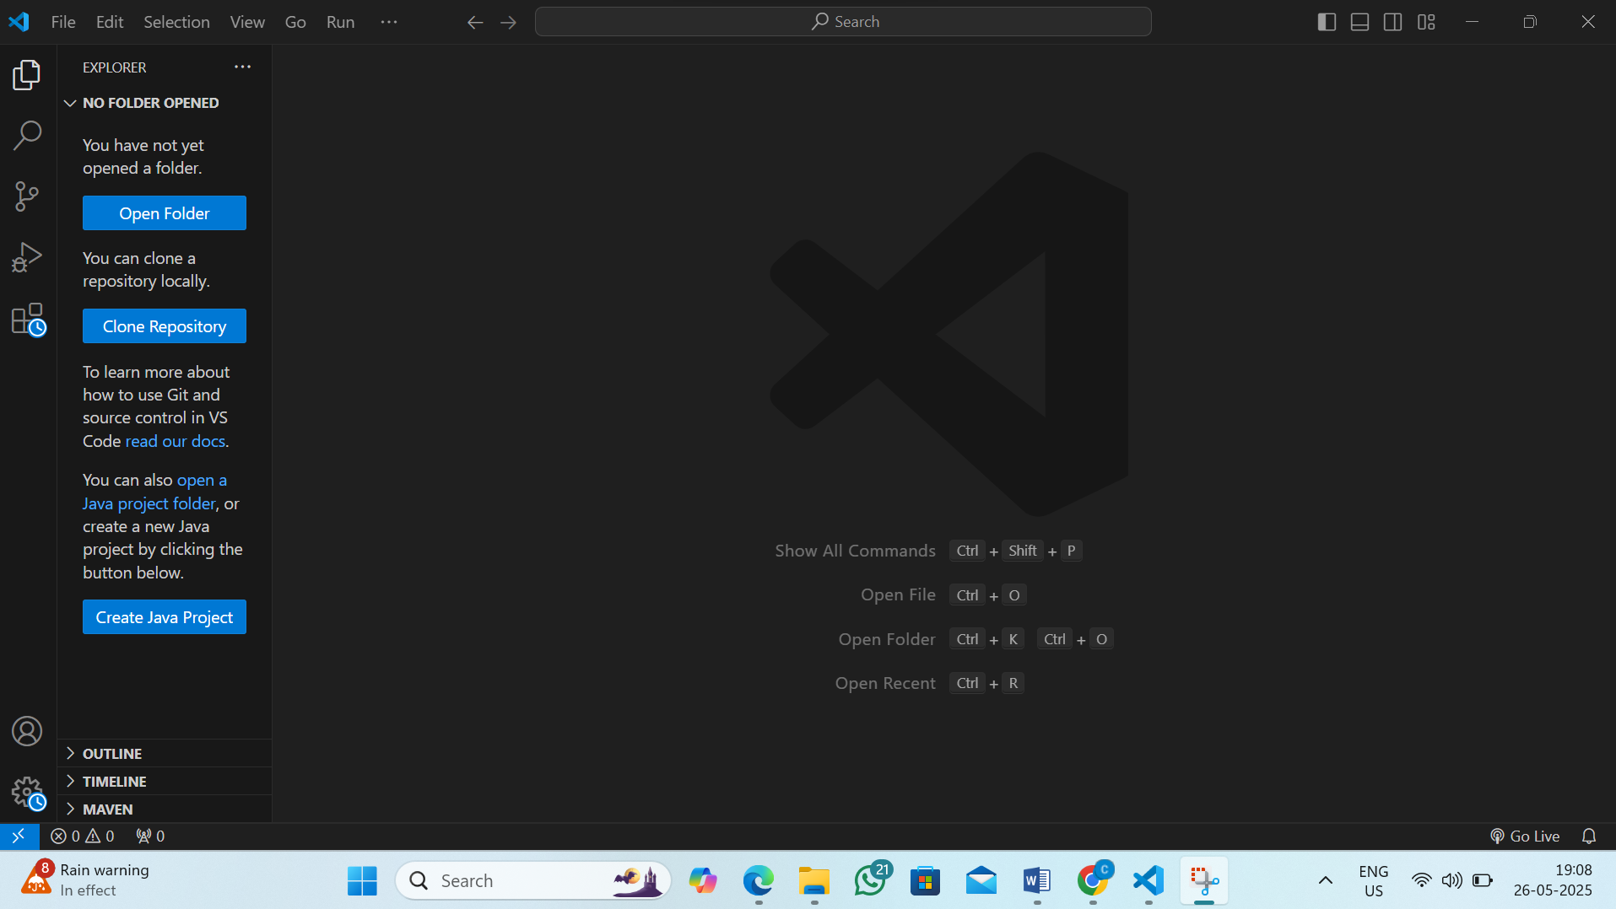
Step2 :Installing python in vs code
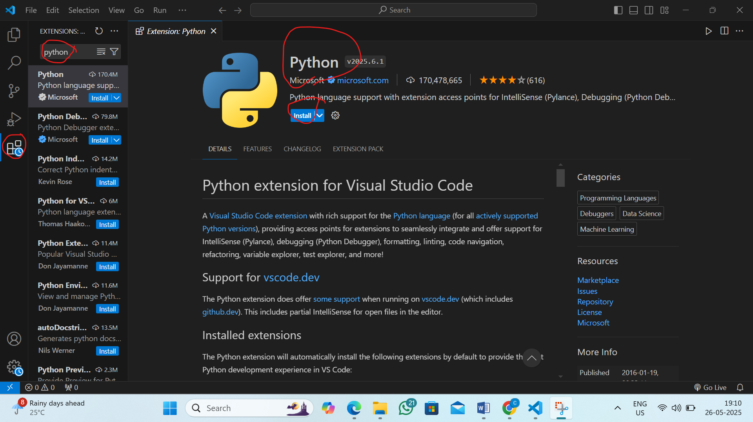

Step3 : Installing terraform in vs code
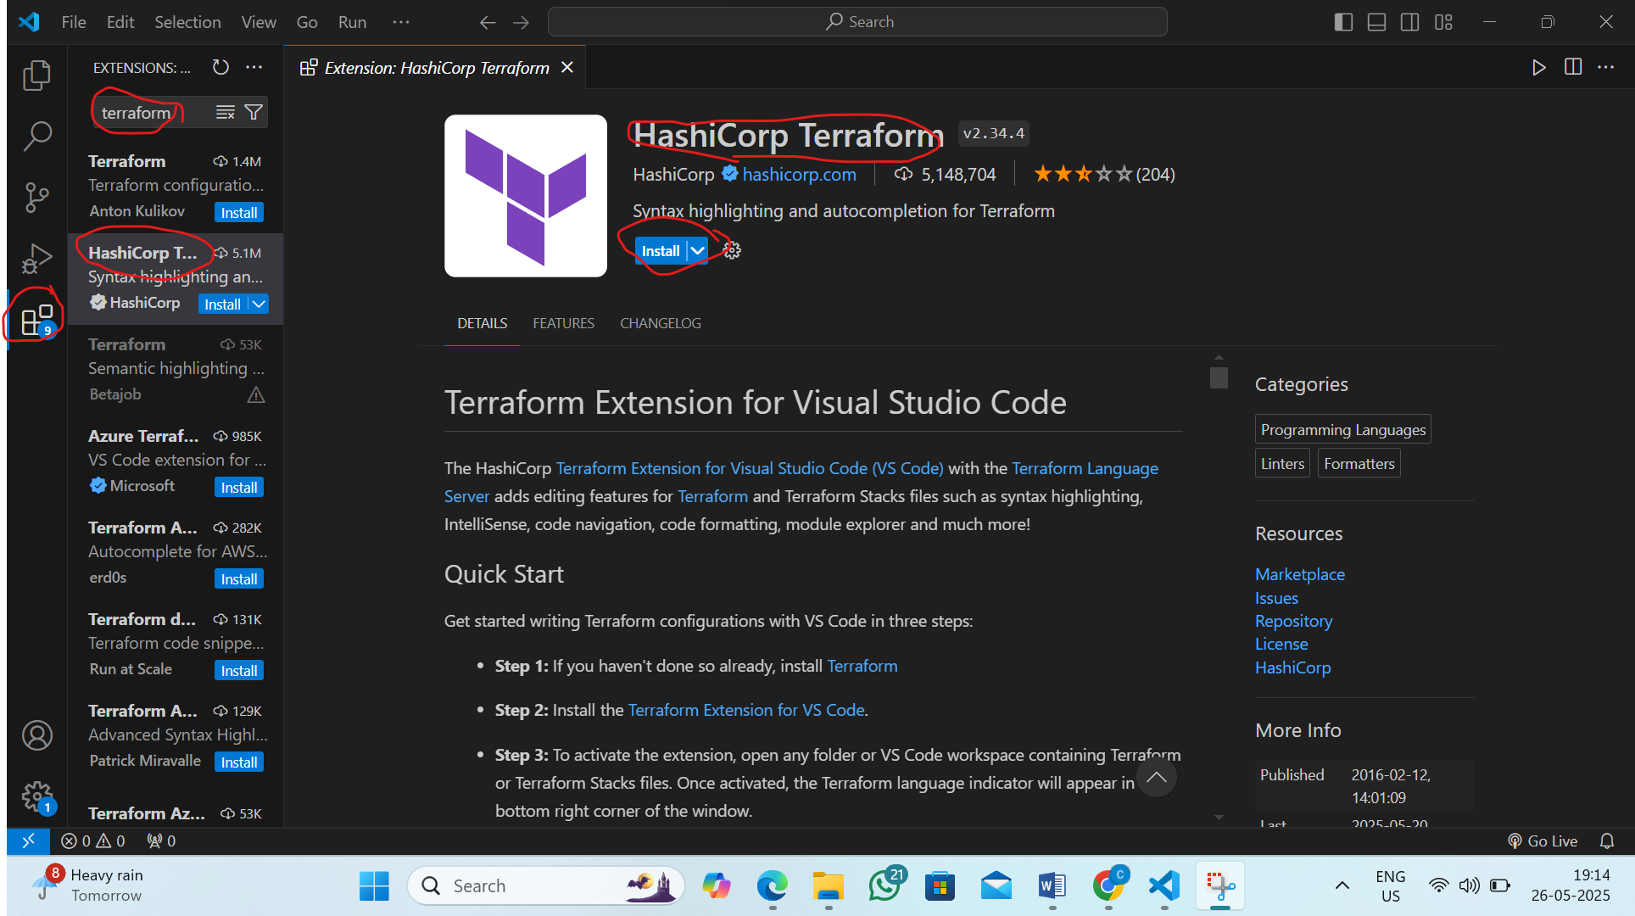
Step4:Final check for python code
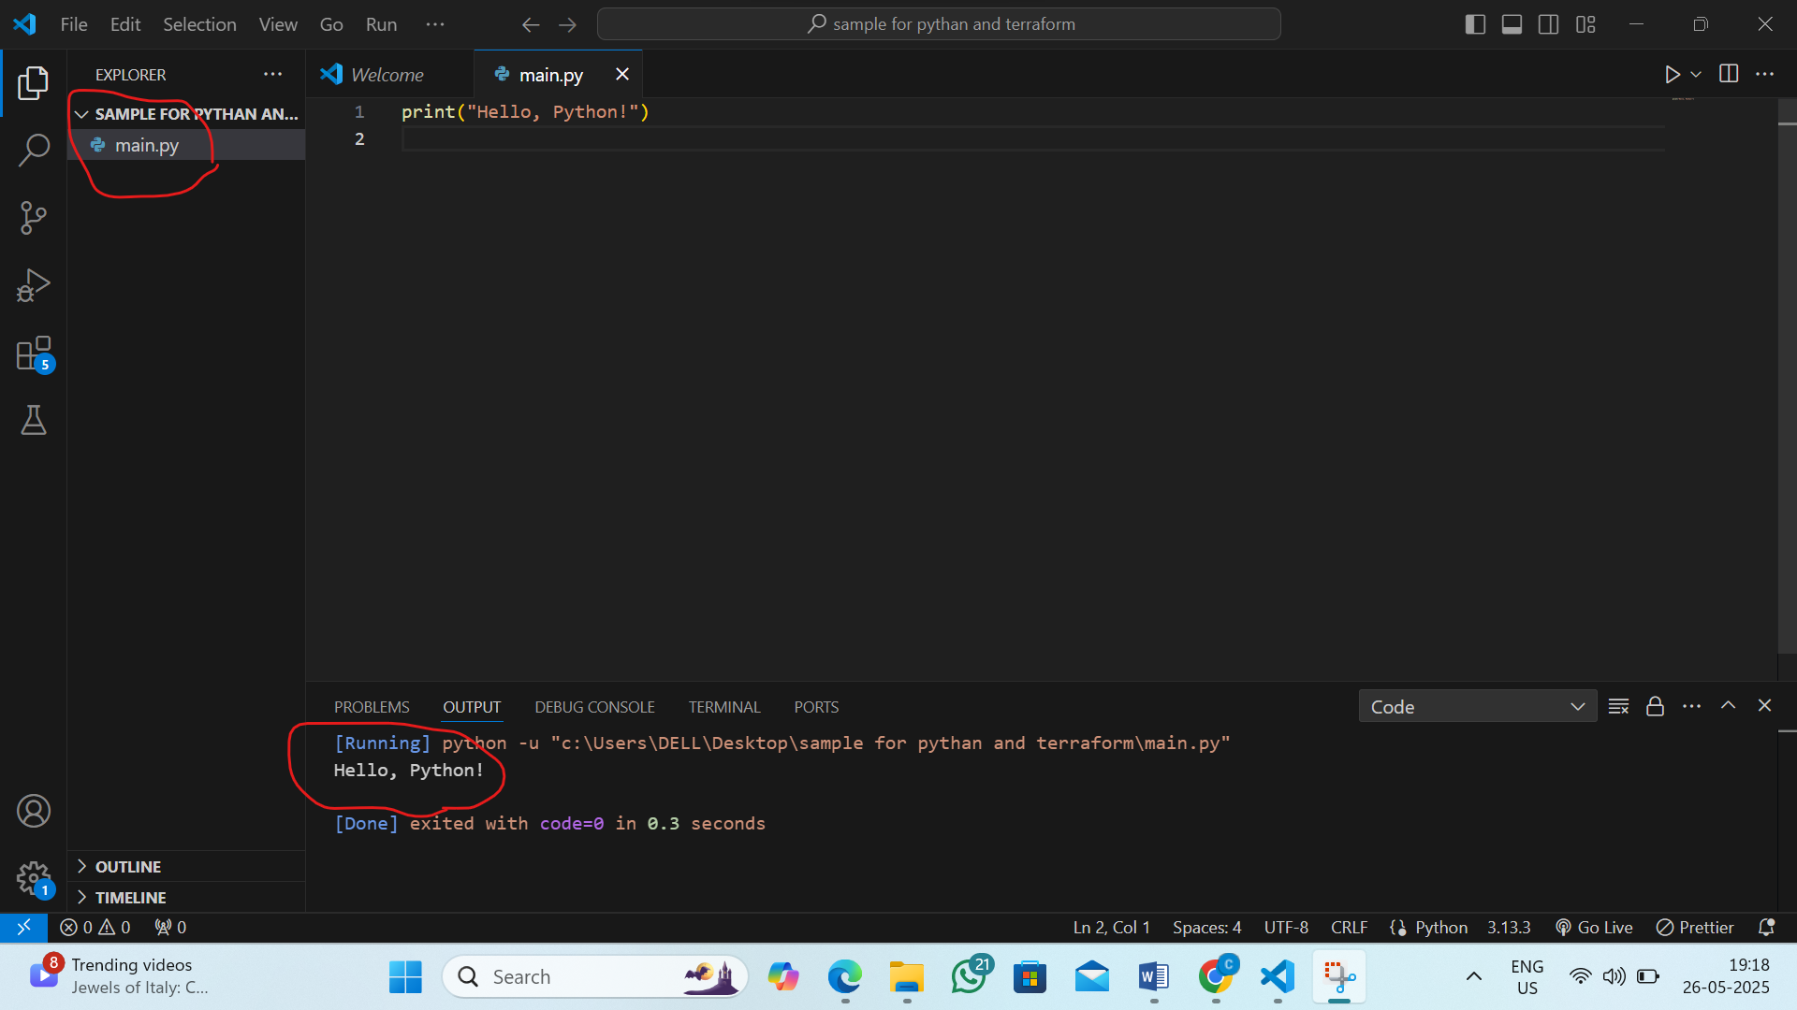

Step 5:final check for terraform
1) Install Terraform CLI on Your System and paste the path in environmental variable
2) Create a Terraform Project in VS Code
3) Run Terraform Commands in VS Code
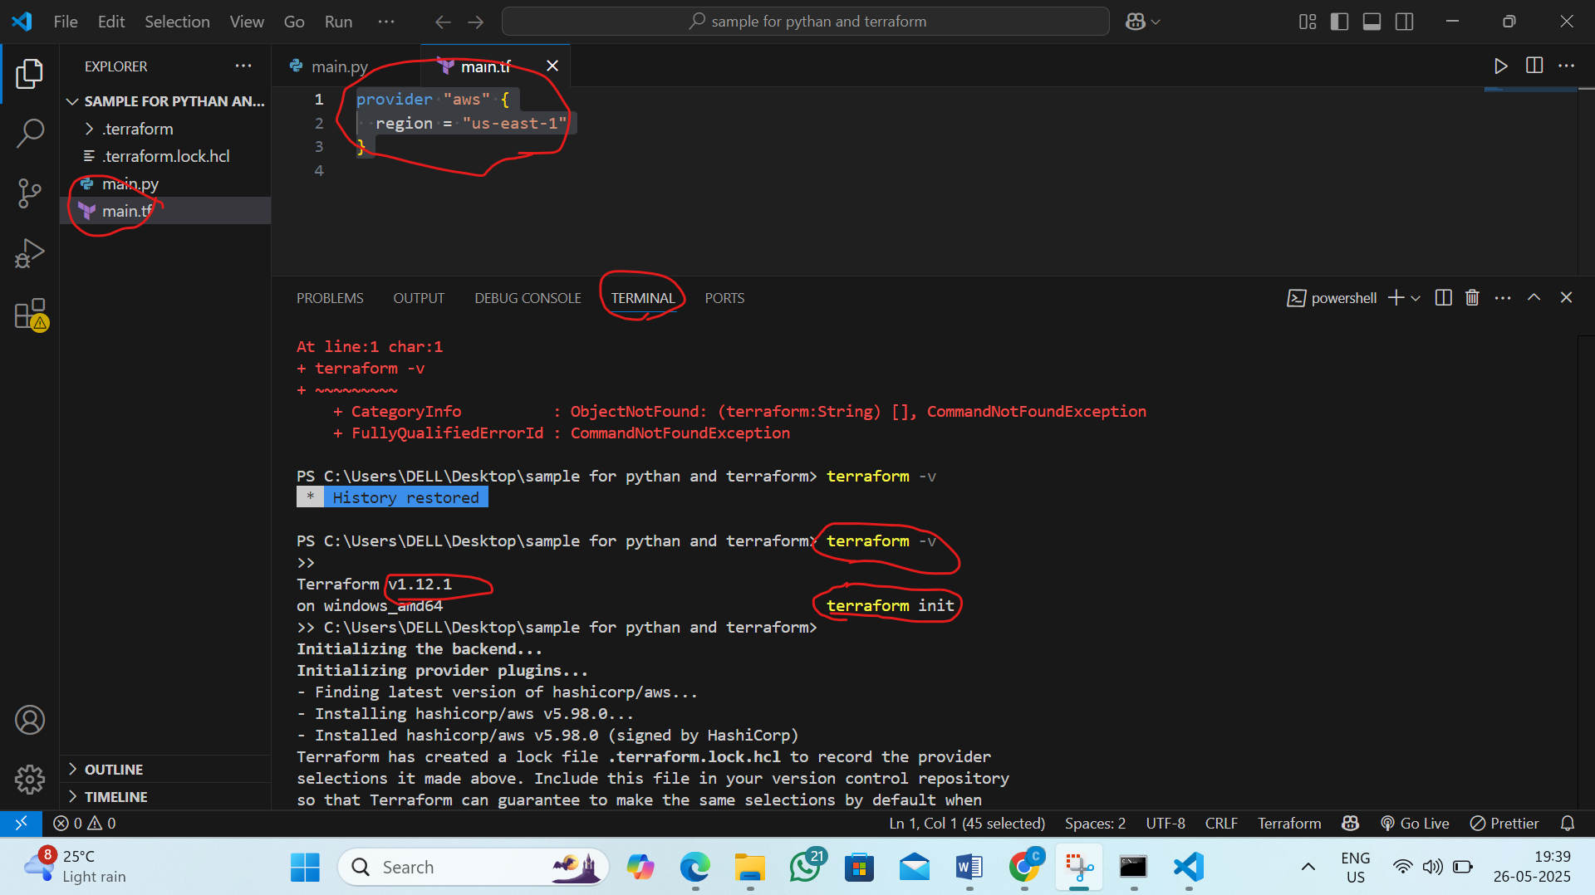
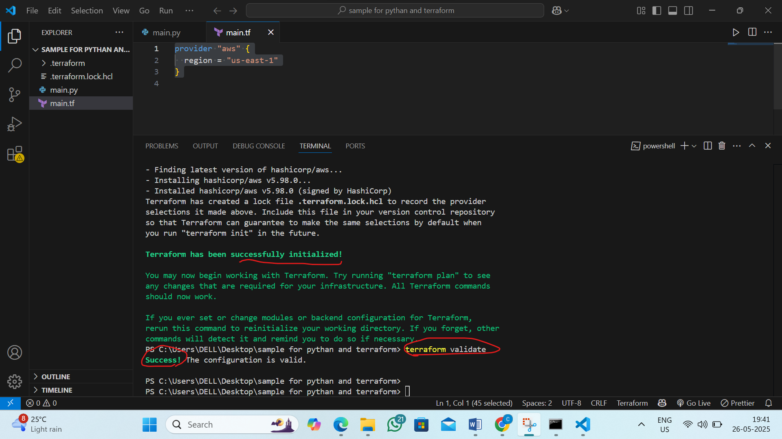

3. L3 - Create Python Console Application to randomly generate OTP kind of secure code
Step 1: Open Any vs Code Editor
Step2 : create the file by extenstion .py (otp.py)
Step3: write the code
Step4:Run the code
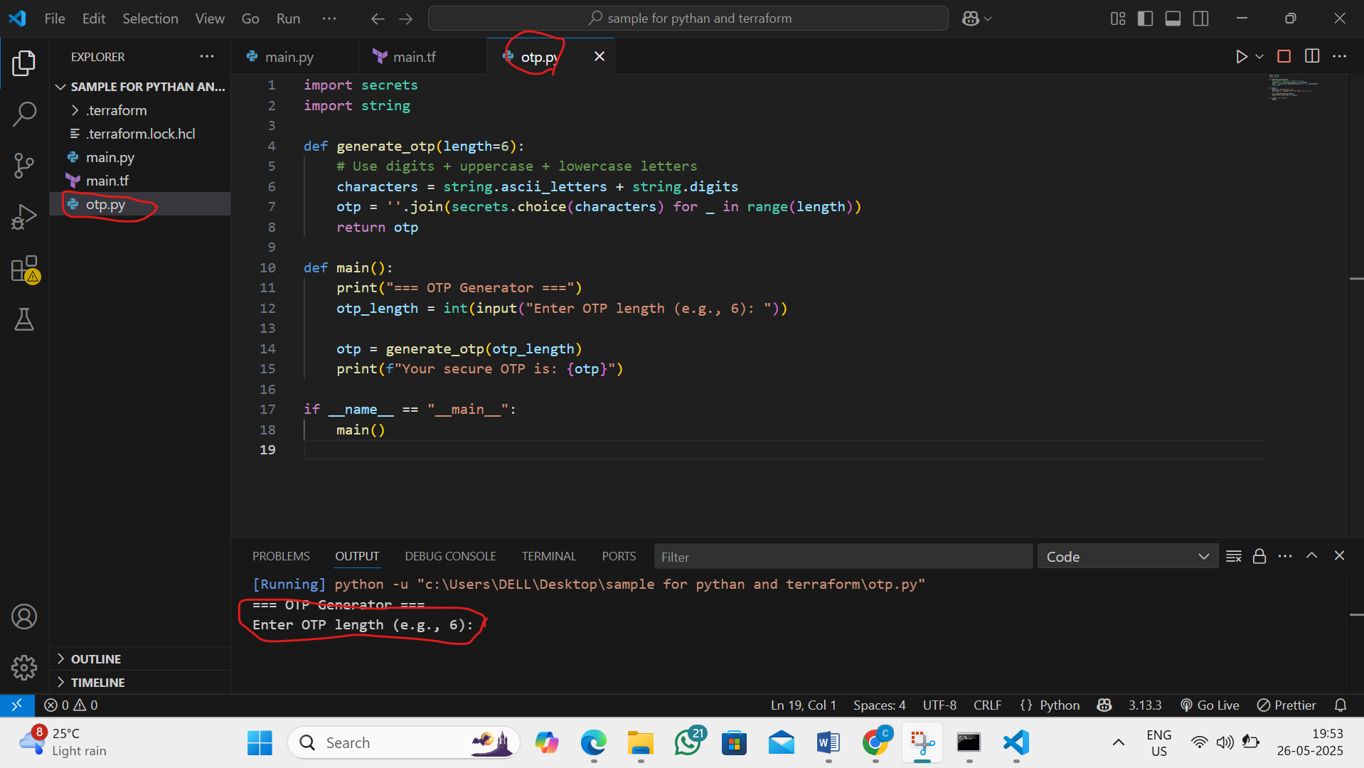
Step2:final output open terminal and follow the commands
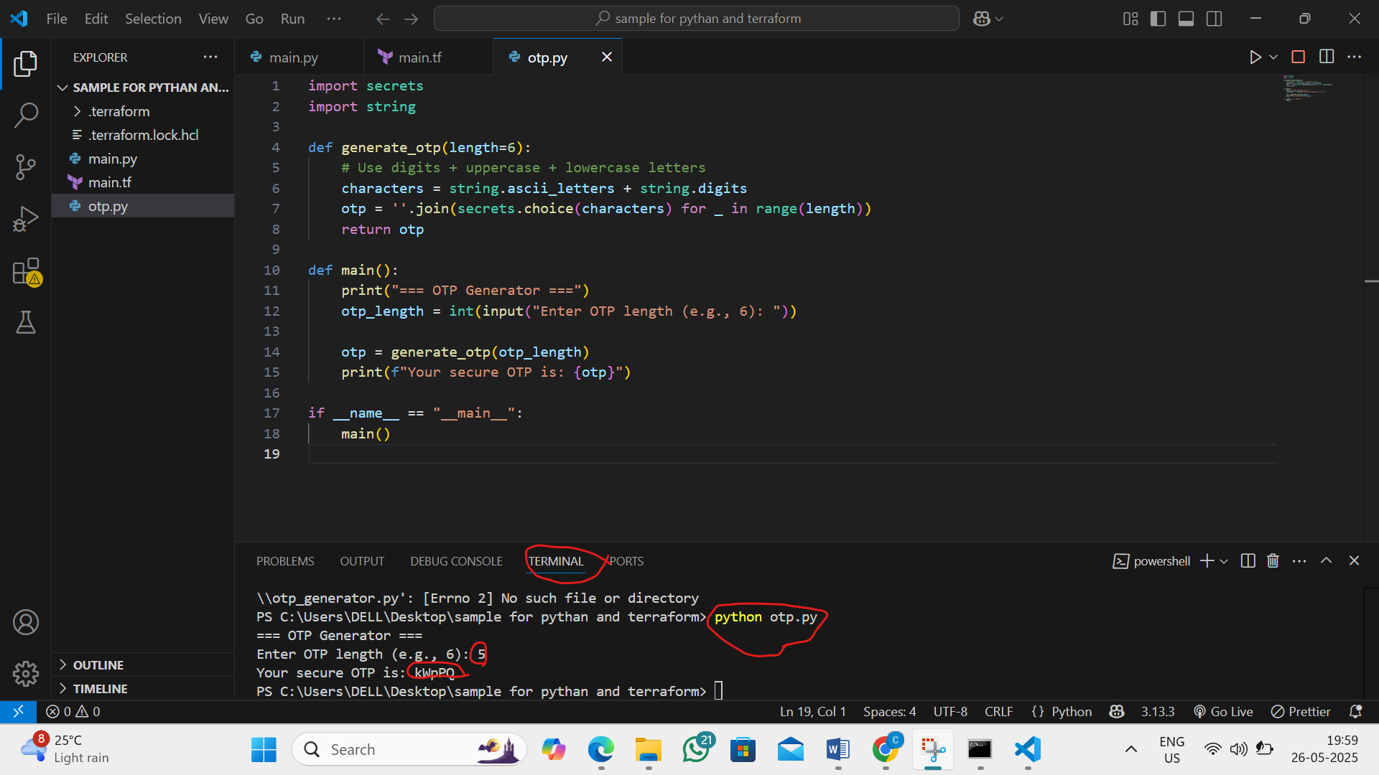

4. L4 - Create Python Console Application to read the contents of .json file and print in the VS Code python console output
Step 1: Create a .json File
- Open VS Code.
- Create a new folder for your project. Example: json_reader_app
- Inside this folder, create a file called data.json.
- Add some sample data in JSON format

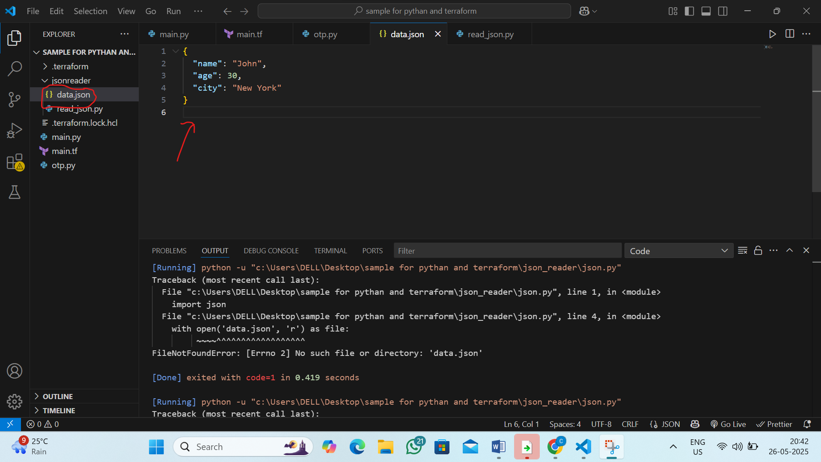
Step 2: Create a Python File and write the code

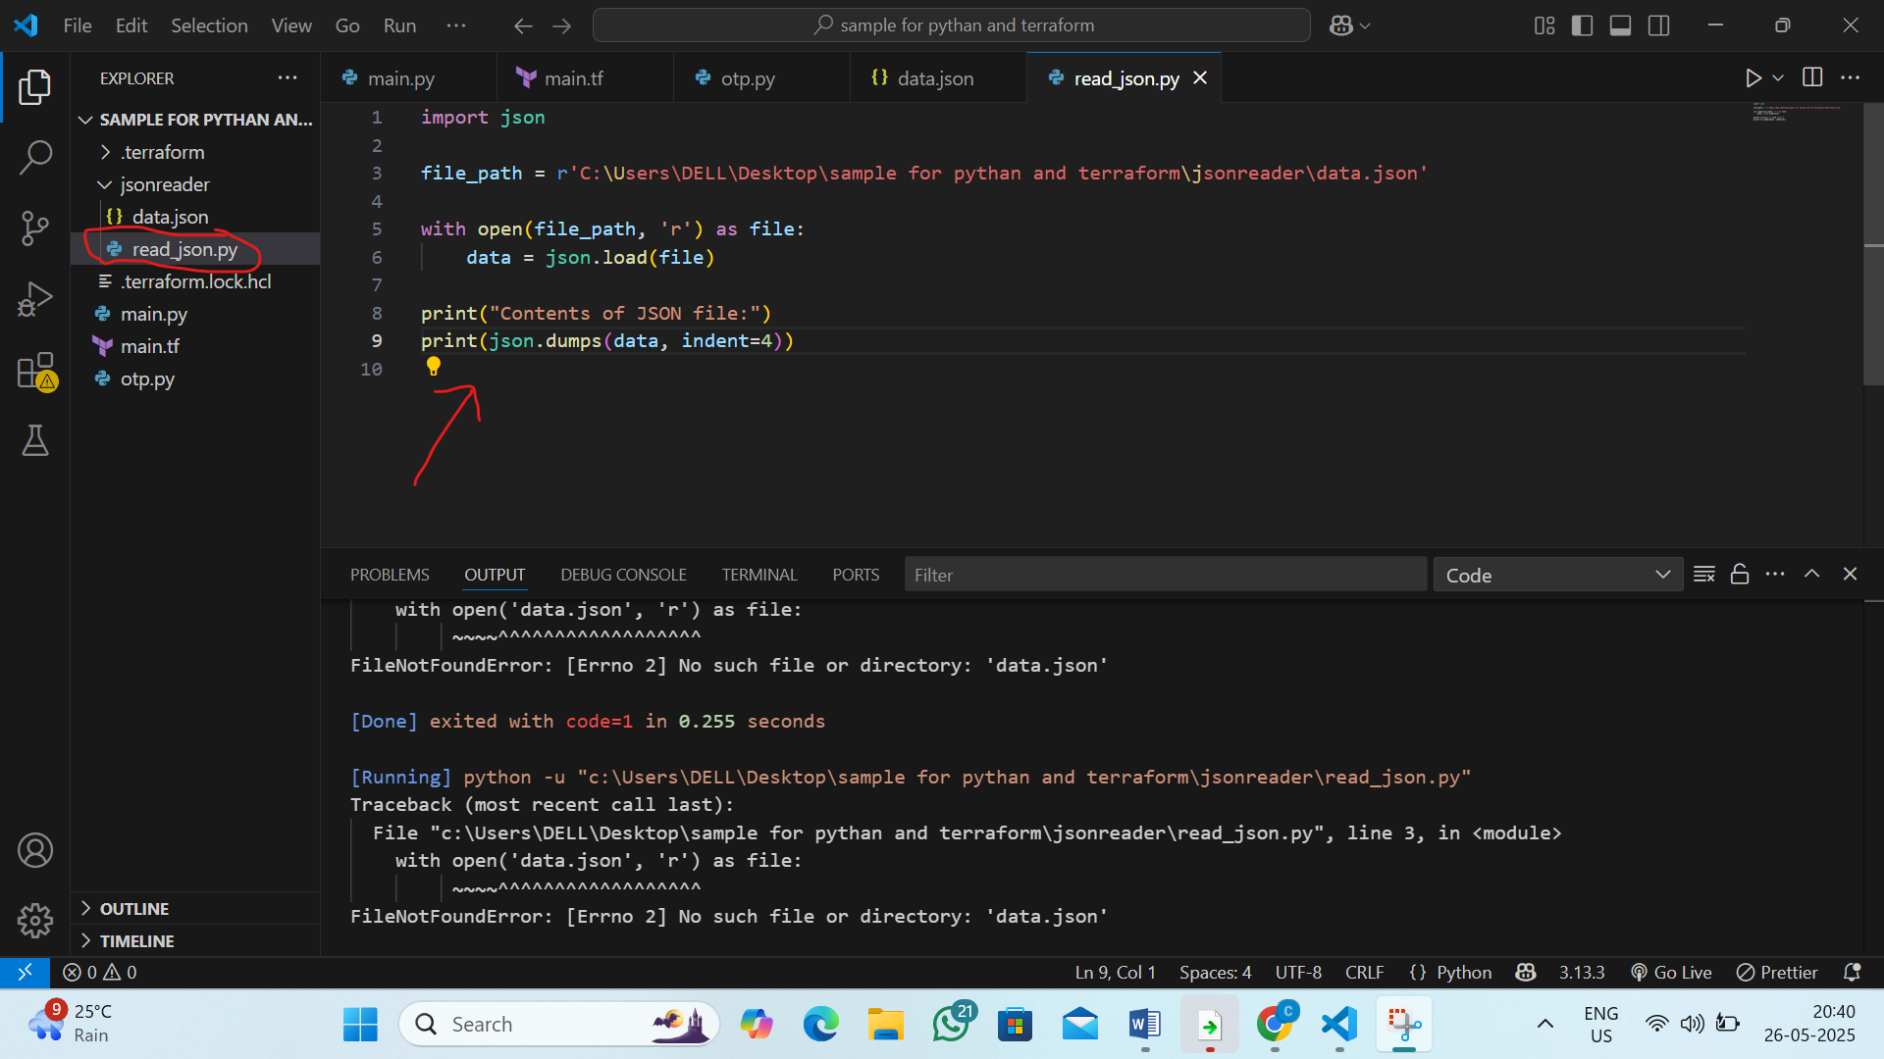

Step 3: Run the Application in VS Code
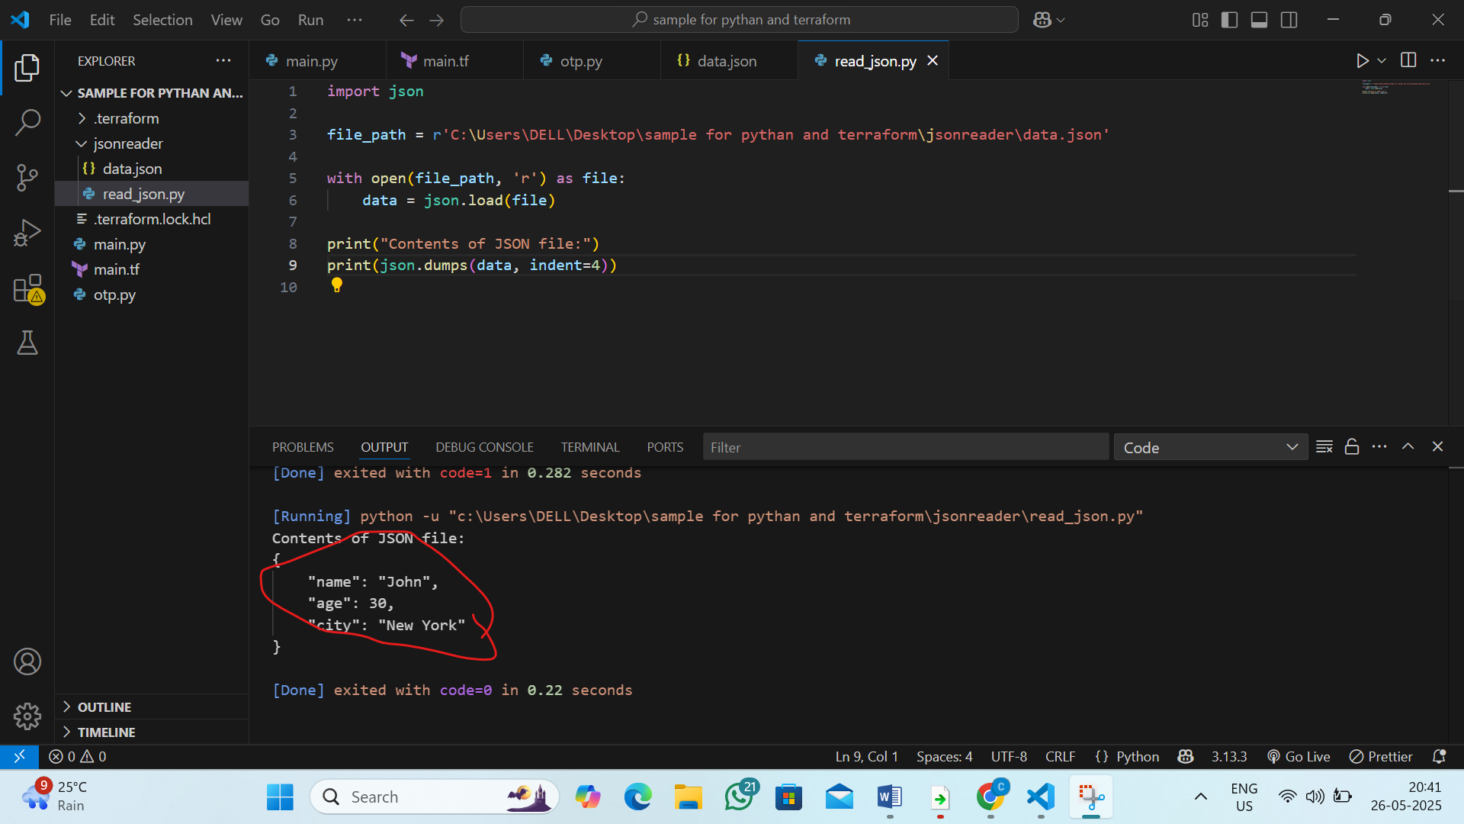

5. L5 - Create Python Web Application to using Flask Web Application Framework

Step 1: Create Project Folder in vs code

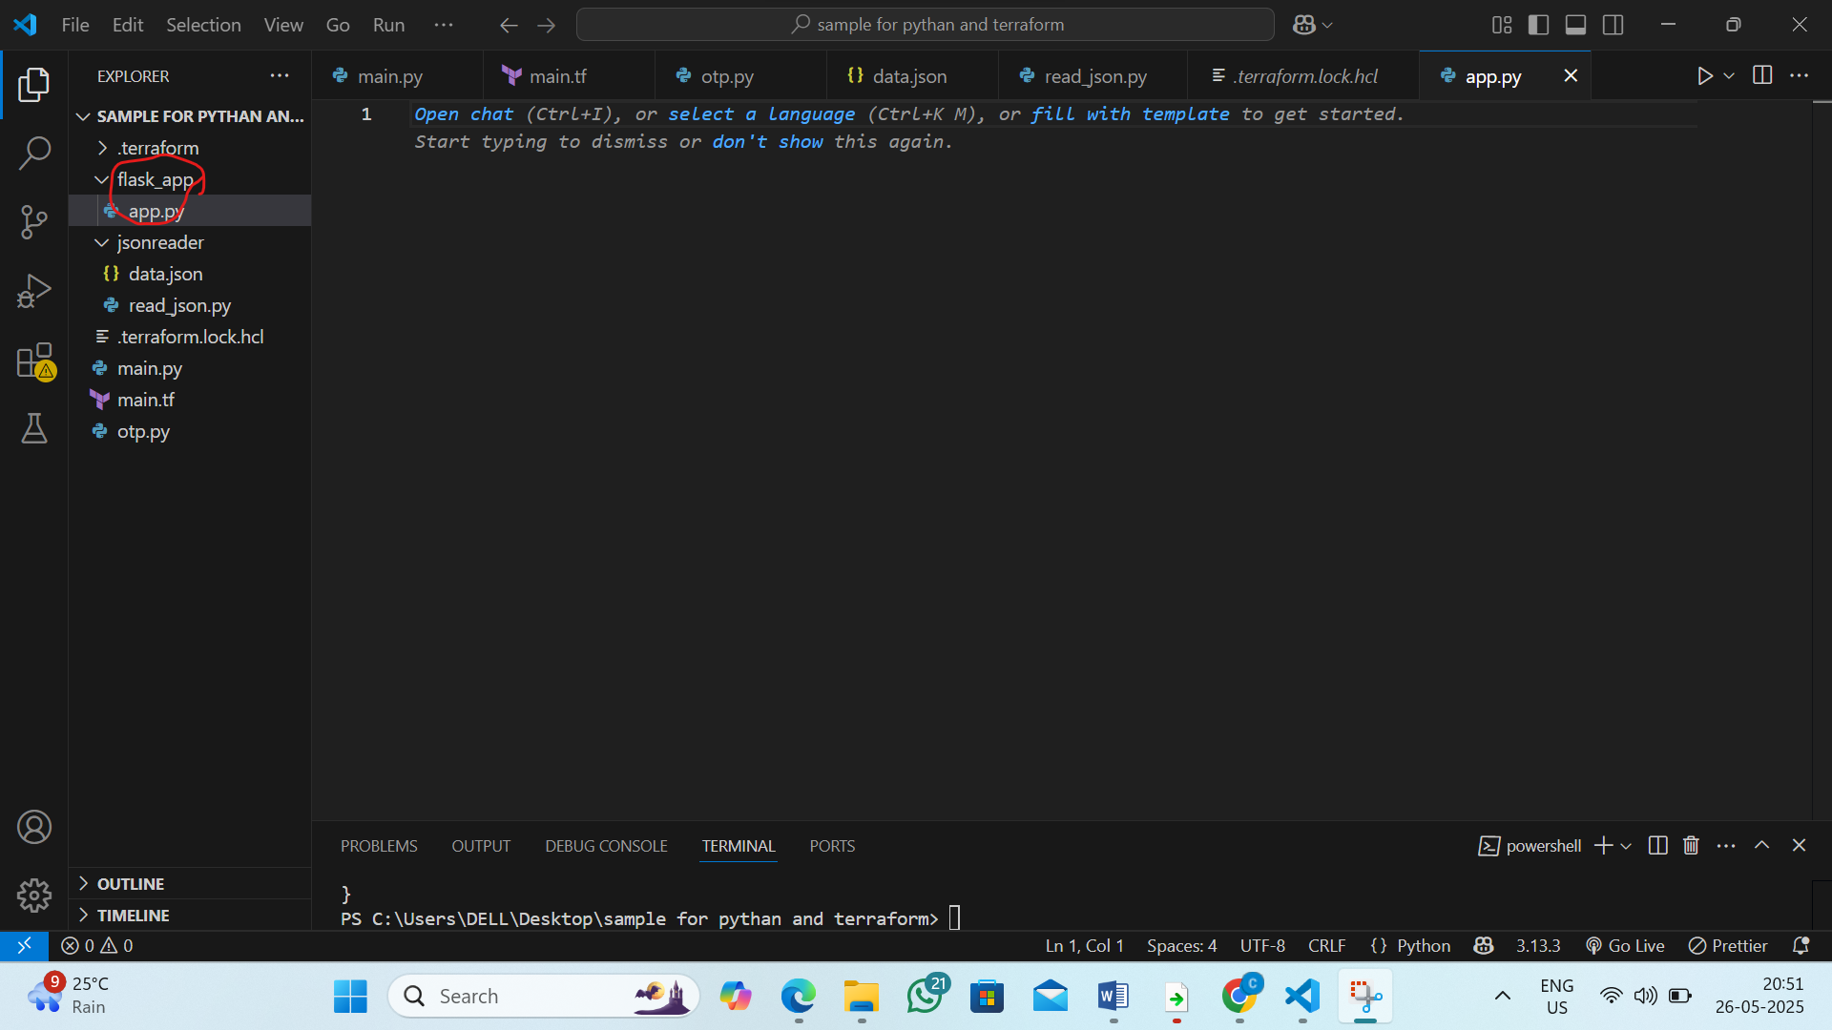

Step2: Install Flask
By the command: pip install flask
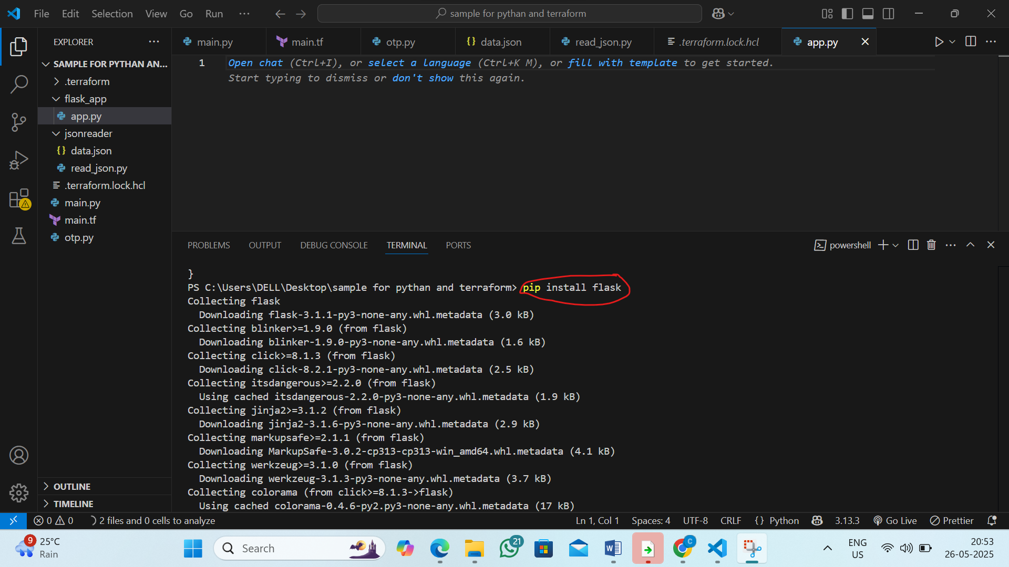

Step3: Write Flask Code (app.py)

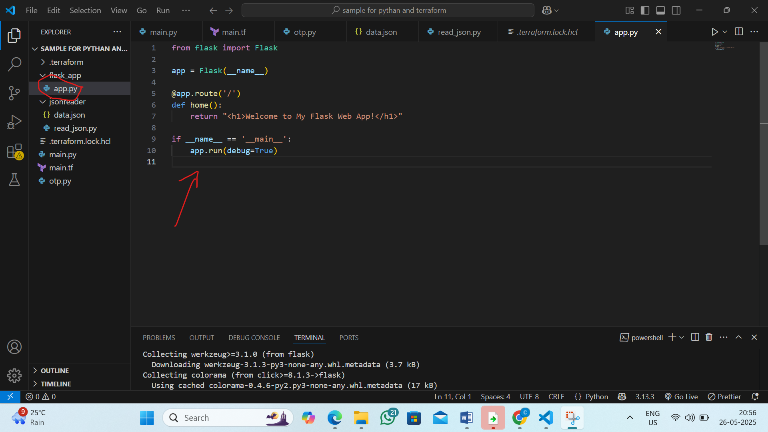

Step4 :Run the code by the following command

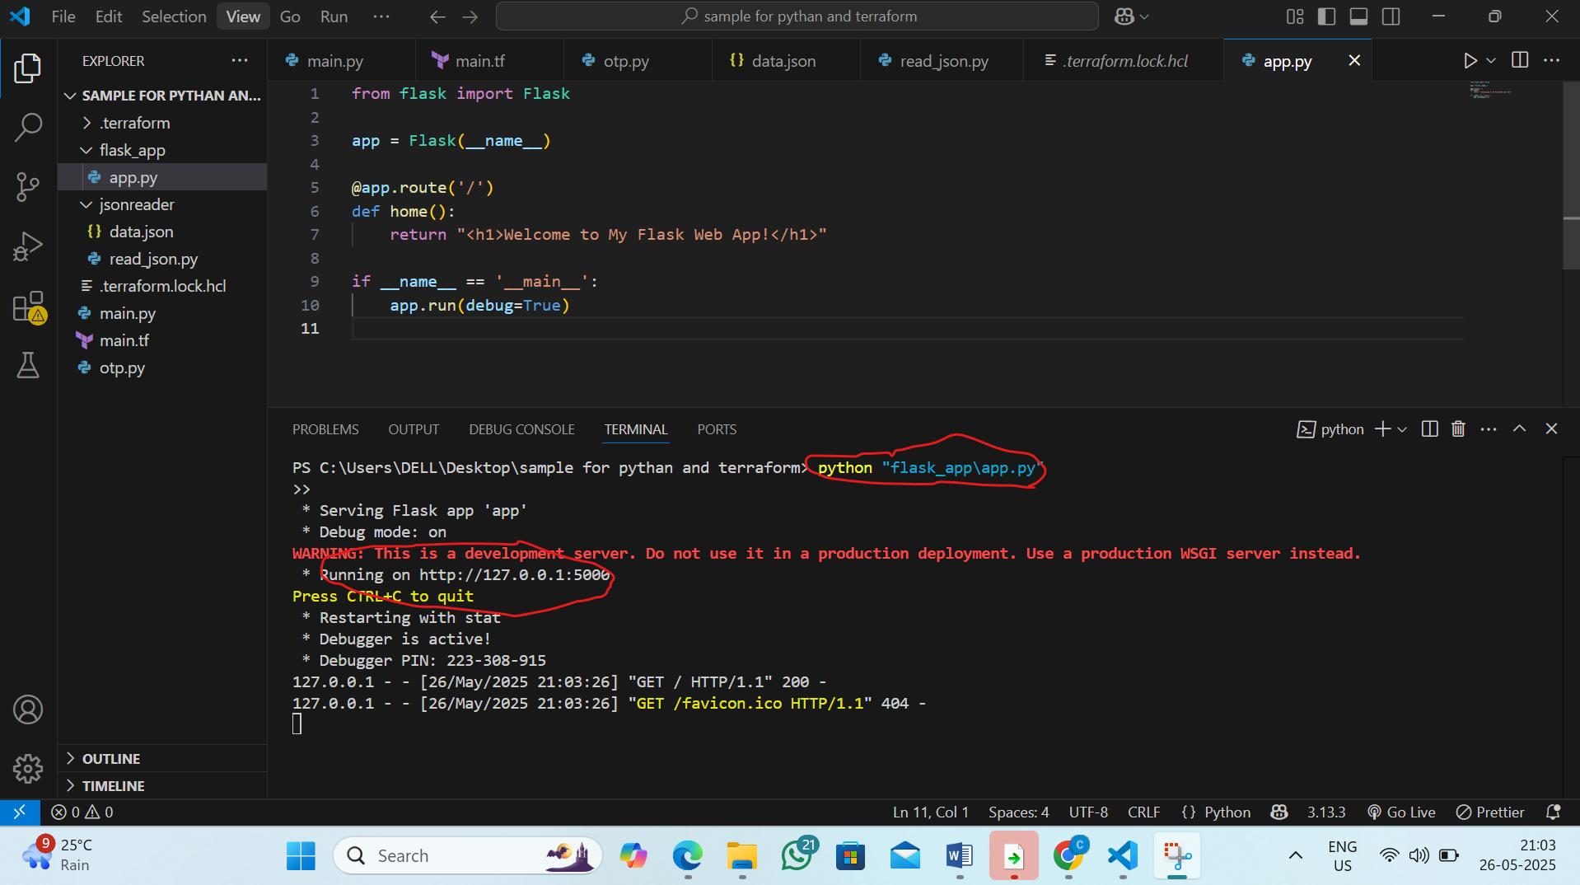

Step5:now in browser paste the link

